**LAPORAN PASCA UTS**

**PEMROGRAMAN WEB DASAR**



|  |  |
| --- | --- |
| **Nama** | : Ghoffar Abdul Ja’far |
| **NIM** | : 2341720035 |
| **Kelas** | : TI 2F |

**JURUSAN TEKNOLOGI INFORMASI**

**POLITEKNIK NEGERI MALANG**

**2024/2025**

1. **Code index.php:**

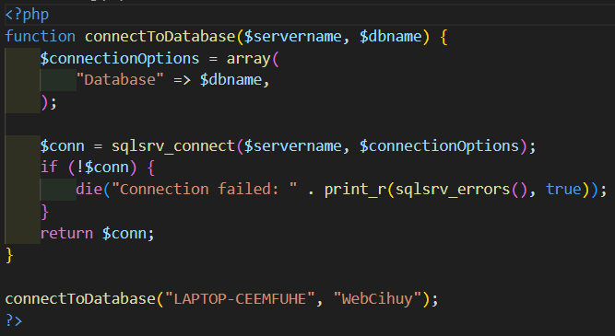

1. **Code index.php:**

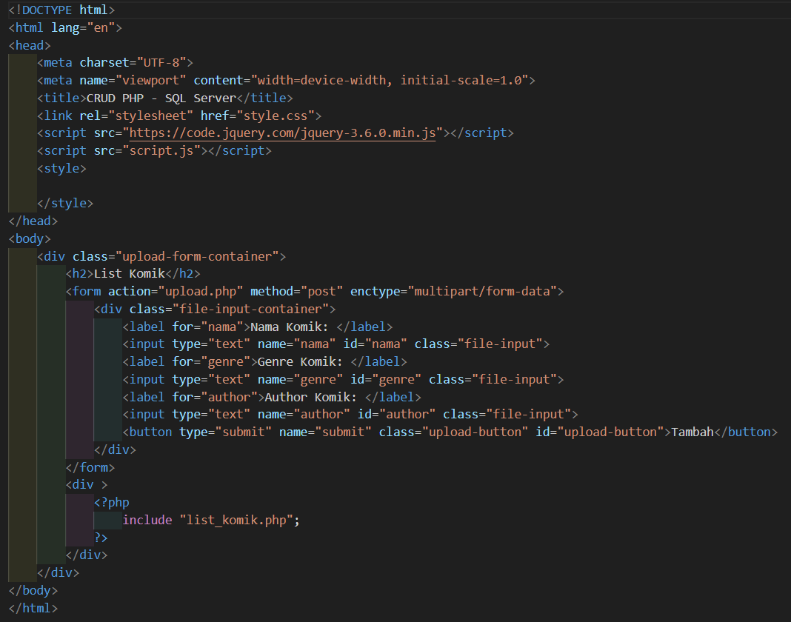

1. **Code upload.php:**

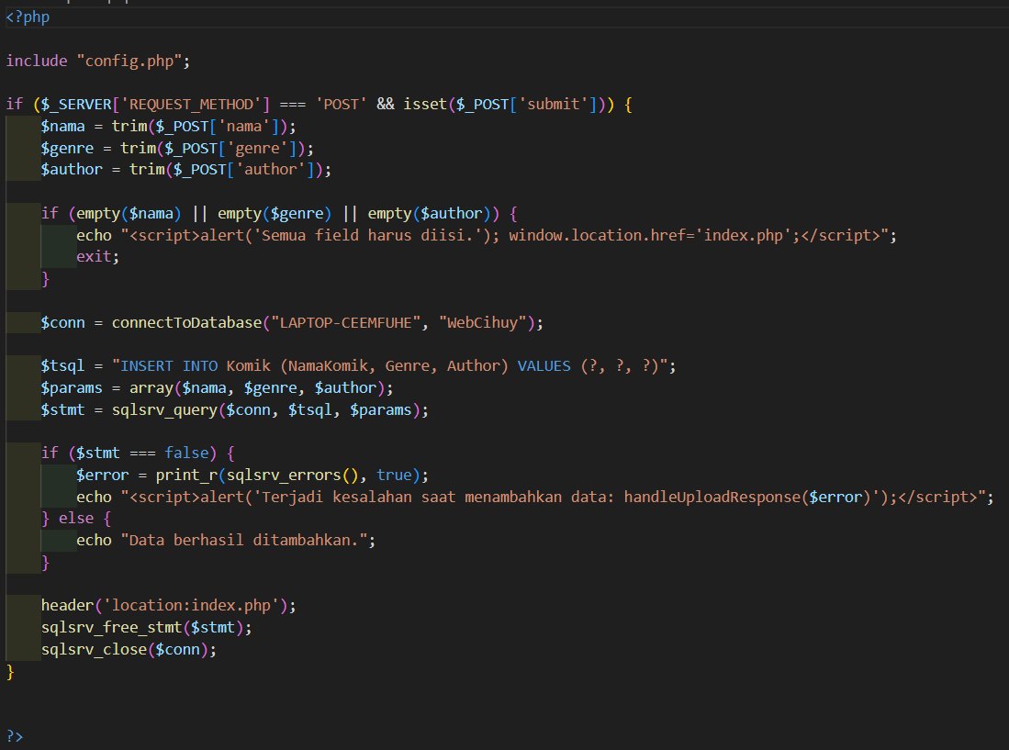

1. **Code list_komik.php:** 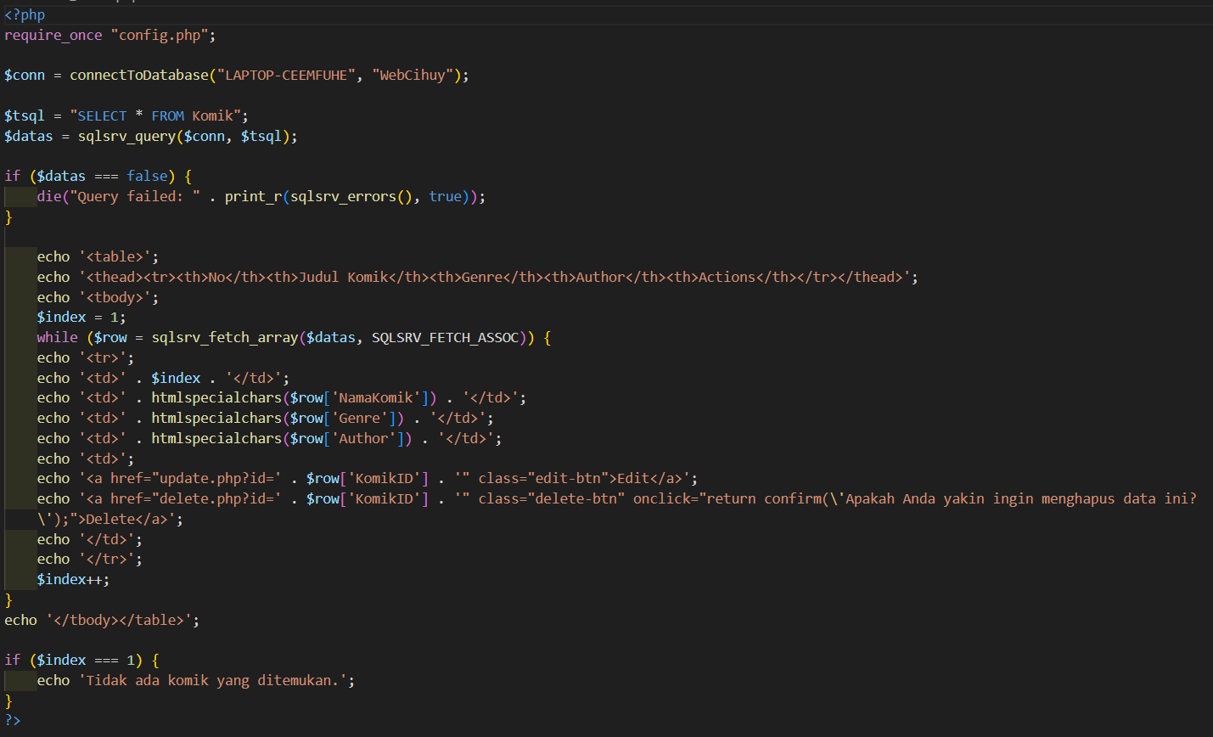
2. **Code update.php:**

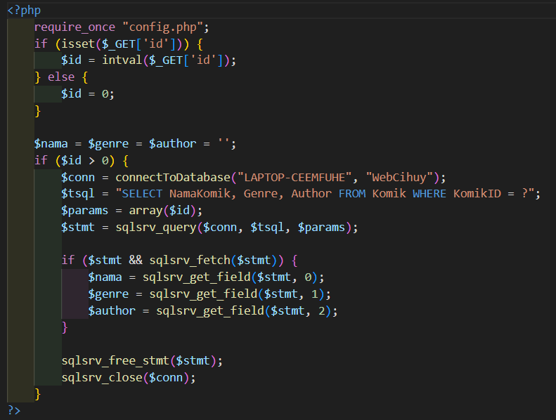

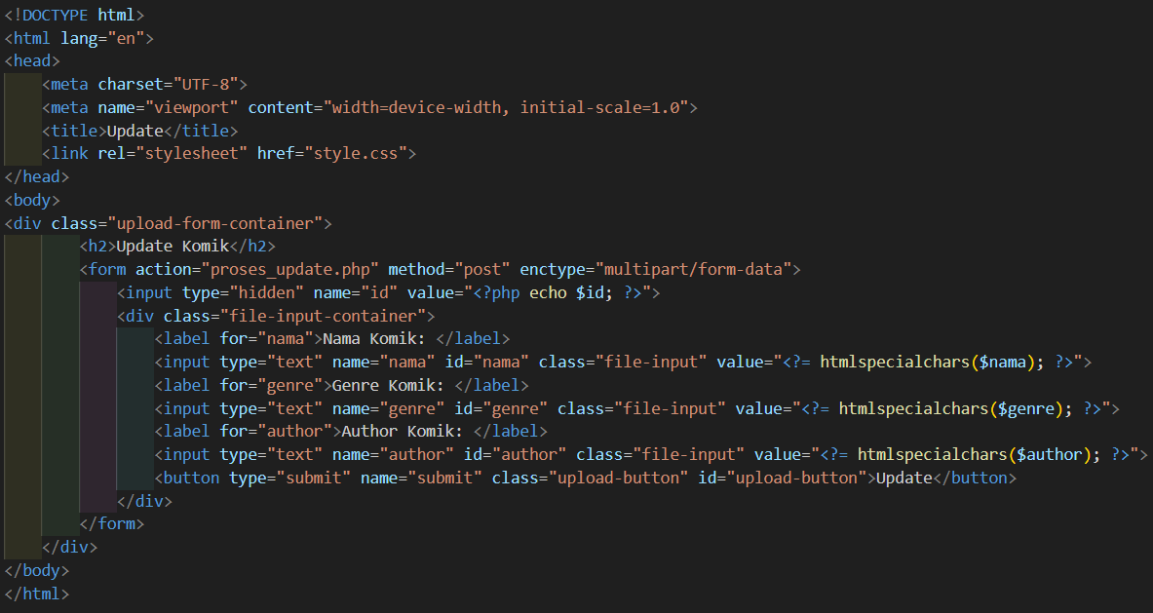

1. **Code proses_update.php:**

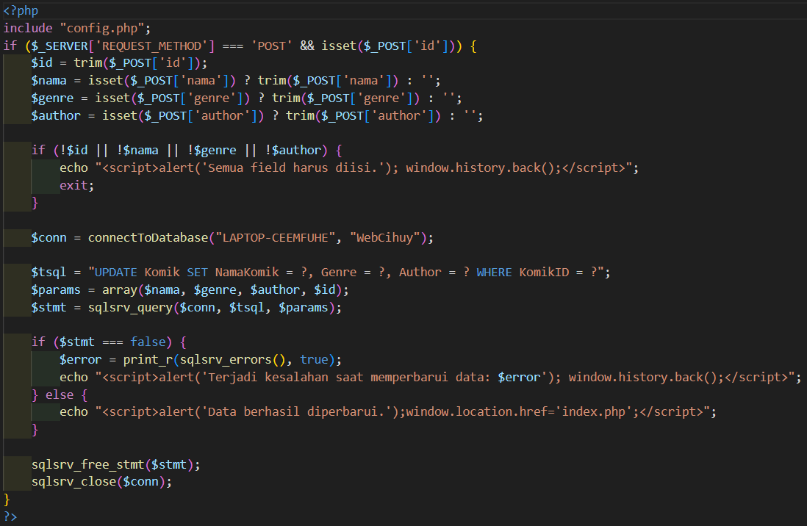

1. **Code delete.php**

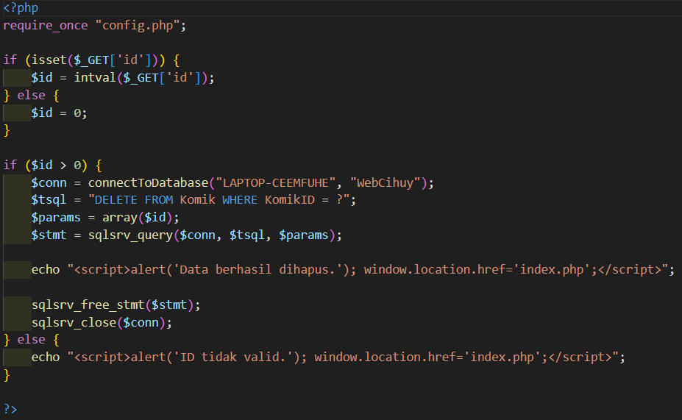

1. **Code style.css:**



